Jojo Rabbit
Questions and Useful Vocabulary
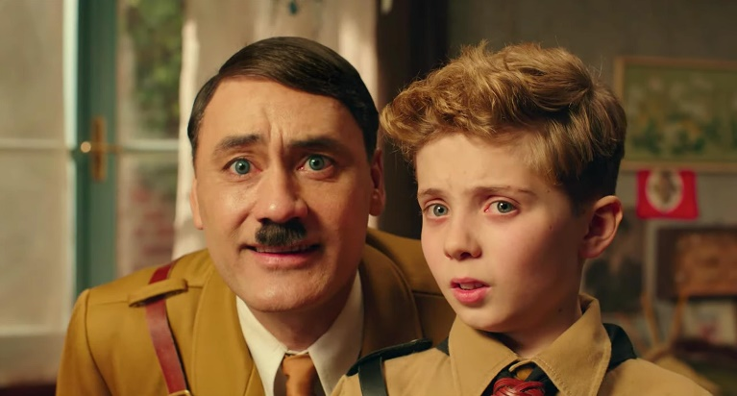

Useful vocabulary:
- imaginary friend
- resistance
- Jew
- hideous
- scar
- privileged
- fiancée
- unlikely friends

Please answer the following questions about the film Jojo Rabbit.
- Who was Jojo’s imaginary friend? Who was his real friend?
- How was Jojo injured?
- Who was Inga? What had happened to her?
- Who was Elsa? What had happened to her and her family?
- What happened to Jojo’s mother? Why?
- Describe your favourite character in the film.
- Describe your favourite scene in the film.
- Did you like the film? Why or why not?
- Would you recommend the film to others? If so, to whom?
- Add 5 more useful vocabulary words to our list of words. They do not have to be in the film, but they must be related to it.

